
  
  
  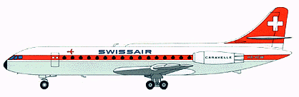
   | Caravelle SE-210 |  |  |  | 
   | Span |  | 34.30 m
   | Lenght |  | 32.00 m
   | Height |  | 8.72 m
   | Powerplant |  | 2 Rolls Royce RA - 29 MK - 527
   | Max. static thrust |  | 2 x 51 kN (5171 kg)
   | Crusing Speed |  | 830 km/h at 10' 000 m
   | Range |  | 2946 km
   | Passenger capacity |  | 80
   | Cockpit / Cabin crew |  | 2 / 4
   | Area of operation |  | Europe

http://www.airliners.de/seiten/indexe.html
Stefano Pagiola has been taking photographs of airliners since 1981. His photographs have been published in a wide variety of aviation publications, including Airways, ACAR, Airliners, Airliner World, Aircraft Illustrated, JP4 Mensile di Aeronautica, and Propliner as well as in several books and calendars. Several have also been produced as postcards.
Images on this site have been scanned with a width of about 800 pixels and average about 50-100k.
All photographs are Copyright Stefano Pagiola. Please read this notice before downloading.
Copyright Stefano Pagiola, 1999
TAE SE-210 Caravelle 10B3 EC-CMS (msn 238) at Geneva on 24 October 1981.
Copyright Stefano Pagiola, 1999
AeroJet SE-210 Caravelle 10B3 HB-ICJ (msn 169) at Geneva in January 1996.
Swiss charter airline AeroJet was one of the last airlines to fly Caravelles in passenger service in Europe. Its single Caravelle, series 10B3 HB-ICJ, is seen here shortly before she was retired in January 1996 because of tightening noise regulations.
For more information on AeroJet and an account of a typical flight on its Caravelle, see my article in Aircraft Illustrated.

Caravelle history
In 1951 the French government formed a special committee (Comité du Materiel Civil) comprised of government and airline representatives, to work out the design specification for a French-built jet transport. The jet-airliner would have to carry up to 65 passengers (+freight) and cruise at 700km/h over 2000km. Six builders submitted proposals , and on March 28, 1952 three of them were selected: Sud-Ouest, Sud Est and Hurel Dubois.
Pierre Satre (the actual Caravelle designer) and his team worked on different proposals of which one was named X-210. This design was powered by French built Atar engines mounted on the tail - the same layout was later also used for the Boeing 727 and DC9. The major aerodynamic benefits of mounting the engines at the rear are twofold: longitudinal stability is affected little by changes of thrust, and the fullest efficiency can be extracted from a completely unhampered wing - so called: aerodynamically clean. A further positive aspect of mounting the engines at the rear is that the noise level in the cabin is very low compared to the dH. Comet or TU 104 where the engines are mounted in the wing just besides the cabin. However a new powerplant was found for the X-210 project - the Avon R.A. 16 jet engine. It can deliver more than 9000lb (the Atar engines could only deliver 6170lb. !). So, the X-210 project had to be revised and in July 1952 it was re-submitted. Just 2 months later the design was officially accepted and in February 1953 work started on two (2) prototypes. One airframe for fatigue testing and the other for static tests.
On July 2nd, 1953 the aeroplane became the S.E.210 (S.E. = Sud Est). For 20 months , work on the completion of the prototypes continued at Toulouse. A special 120.000 cu. M fatigue tank was built to test the Caravelle airframe to destruction. Air France attached flight personal, to assist the Sud Est team. De Havilland later sent some engineers to Toulouse and made available much data arising from their own Comet (visit www.surf.to/Comet) experience. That is why the Caravelle has an identical nose and a very similar cockpit layout - the French government paid a fortune to use their Comet nose.
On April 21st, 1955 the first flying prototype was rolled out for taxiing trials. The maiden flight was made on 27th of May 1955, lasting 41 minutes. Within the next eleven months, F-WHHH and later F-BHHH had flown 411 hours in 173 flights to complete the certification program.
Air France had placed an order for 12 Caravelles in February 1956. SAS (Scandinavian Airline System) ordered 6 Caravelles in June 1957, followed by Varig (Brazil) in October. That spring, the second prototype had flown 50.000km around the world on its sales tour in North and South America. So the Caravelle became the first twin jet airliner to cross the Atlantic. The French certification of the prototypes was received on April 2nd, 1958.
The first production Caravelle flew on May 18, 1958 /F-BHRA). The production model was slightly longer but very similar to the prototype. On April 2, 1959 Air France took over the first Caravelle. Sud Est merged with Ouest-Aviation to Sud Aviation in 1957 but she retained its SE210 designation.
The first Caravelle service was flown by SAS on April 26, 1959 as SAS leased the second prototype for crew training. Ten days later Air France introduced its first Caravelle in commercial service (Paris - Istanbul).
The first significant change came with the Caravelle III (3) which was equipped with more powerful Avon Mk. 527 engines allowing higher loads and improved performance. All the first Caravelles (all 1 and 1A) except 3 were later upgraded to series III standards. In 1960 more than 100 Caravelles were flying in all parts of the world. United ordered 20 Caravelles in February 1960 - they ordered the new Caravelle 6R the series 6 aircraft became the standard model in 1961. The 6R featured reverse thrust. However, to receive FAA certification the Caravelle 6 Rs for United had to be changed to comply with US regulations. The most noticeable difference are the larger cockpit windows and the removal of the dorsal fin (the long fin on top of the fuselage), that housed avionics. The 6R's not built for United did have the dorsal fin, though. United introduced the Caravelle 6R on July 1961 between New York and Chicago. One more Caravelle (a series 3) was sold to the US: General Electric purchased it for engine testing.
Sud Aviation continued to improve the Caravelle. In Europe Caravelles were now flying for : Sabena, Air France Alitalia, JAT, SAS, Swissair, TAP and Austrian Airlines, many of which 6N's, visually identical to the III, but powered by the Avon Mk 531.
In 1964 Sud Aviation built the Caravelle 10A (with GE engines)which was delivered to Sterling, Finnair and Syrian Arab Airlines. The major change of this Caravelle is the extension of the wing leading edge at the root as well as the bullet at the intersection of the rudders and the tailplane. Starting with United order of the Caravelle all Caravelles had the larger cockpit windows. The 10A, also called "Caravelle Horizon", with GE engines, never saw production, only one was built. The production model was called 10B and used the JT8D. Cabin windows were raised by 20 cm and an APU was installed in the tail cone. Some had a dorsal fin. The fuselage was stretched by 1 m (33.01m).
In 1965 Sud offered the series 10R - very similar to the 6R but using Pratt & Whitney engines JT8D-7 (same powerplant used for the 737, 727, DC 9). The Caravelle 10R made its first flight on January 18th, 1965 followed by the Caravelle 11R which had a large cargo door on its right side, just ahead of the wing. This was a combi Caravelle carrying passengers and cargo at the same time. The 11R made her first flight on April 21, 1967 and flew with Air Afrique, Air Congo and Transeuropa.
Finally Sud Aviation became part of Aerospatiale in 1970. Now Aerospatiale built the last Caravelle version - the Caravelle 12 with a very long fuselage (36.23 m). This version could carry up to 140 passengers and included the more powerful Pratt &Whitney engines JT8D-9. It made her first flight in 1970 and was built for 3 years until the whole Caravelle construction line was abandoned. The 12 was flown by Air Inter and Sterling that operated the type on their transatlantic routes (with extra tanks of course).
A total of 282 Caravelles were built in Toulouse and the Caravelle paved the way for the modern Airbus types. The last European Caravelle operator was Air Provence which operated the "lady" until late 1996. The prototype of the Caravelle is still in existence however not in a museum but in a technical school in France. In all not more than 11 Caravelles are still flying in South America and Africa. In Europe we have only one Caravelle still in flying condition. It is a series 3 ex SAS Caravelle currently parked at Stockholm Arlanda waiting for sponsors for the restoration.
Above: by Nils Alegren. Visit the Caravelle Homepage to find out all about the Caravelle.

Caravelle 1
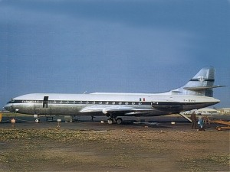
Caravelle 1 Prototype, picture by Robert D. Archer
Caravelle 1
Wing span: | 34.30 m
Length: | 32.01 m
Height: | 8.72 m
Max T/O weight: | 46.000 Kg
Fuel capacity: | -
Cruising speed: | 805 km/h
Range: | 1700 km
Passenger capacity: | 89
Crew: | -
Engines: | 2x RR Avon 522, thrust: 11.400 lb

download: Swissair Caravelle 1 by Rob Bennis

Caravelle 3
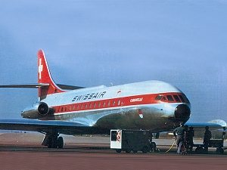
Swissair Caravelle 3, picture by Nils Alegren
Caravelle 3
Wing span: | 34.30 m
Length: | 32.01 m
Height: | 8.72 m
Max T/O weight: | 46.000 Kg
Fuel capacity: | -
Cruising speed: | 805 km/h
Range: | 1700 km
Passenger capacity: | 89
Crew: | -
Engines: | 2x RR Avon 527, thrust: 11.400 lb

download: SABENA Caravelle 3 by Rob Bennis

Caravelle 6
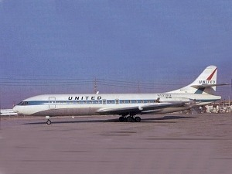
United Caravelle 6, picture by Ted J. Gibson
Caravelle 6
Wing span: | 34.30 m
Length: | 32.01 m
Height: | 8,72 m
Max T/O weight: | 46.000 Kg
Fuel capacity: | -
Cruising speed: | 820 km/h
Range: | 1700 km
Passenger capacity: | 89
Crew: | -
Engines: | 2x RR Avon 533, thrust: 11.400 lb

download: Luxair Caravelle 6 by Rob Bennis

Caravelle 10
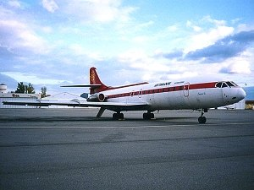
Air Toulouse Caravelle 10, picture by Nils Alegren
Caravelle 10
Wing span: | 34.30 m
Length: | 32.02 m
Height: | 8.72 m
Max T/O weight: | 52.000 Kg
Fuel capacity: | -
Cruising speed: | 845 km/h
Range: | 2700 km
Passenger capacity: | 99
Crew: | -
Engines: | 2x PW JT8D-7, thrust: 14.000 lb

download coming soon

Caravelle 12
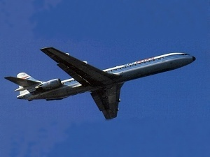
Air Inter Caravelle 12, picture by Nils Alegren
Caravelle 12
Wing span: | 34.30 m
Length: | 36.23 m
Height: | 8.72 m
Max T/O weight: | 55.000 Kg
Fuel capacity: | -
Cruising speed: | 812 km/h
Range: | 2500 km
Passenger capacity: | 107
Crew: | -
Engines: | 2x PWJT8D-9A, thrust: 14.000 lb

download coming soon | Back to the aircraft index

