http://www.netcomuk.co.uk/~lesb/canb02.html



The Meteor and Vampire were already flying - jet engined aircraft had arrived on the scene and were in service. It became obvious that the next step was to produce a jet bomber. In 1944, The Ministry of Aircraft Procurement issued a specification calling for design concepts for a fast, high-altitude, jet-powered medium bomber to replace the Whirlwind / Typhoon / Mosquito style of aircraft. A Ministry of Aircraft Production requirement evolved which sought a jet engined medium bomber and it was initially considered that this new aircraft would take the RAF's Main Force into the jet age with a jet bomber which would be suitable until the heavy bombers, (the "V" bombers), were developed. At English Electric Aircraft at Preston (UK), W.E.W. Petter took up the challenge and in the same year, 1944, conceived the aircraft that was to become the world-famous Canberra.  The Canberra was initially envisaged as a single engined, straight winged bomber with a circular cross-section (to ease the problems inherent at that time in pressurising aircraft), but this idea was soon dropped in view of the limited bomb and fuel capacity that would be imposed. An aircraft with engines mounted at the wing roots was considered but wing-mounted engines became favoured when the Rolls Royce Avon 109, an engine of relatively small overall diameter, became available. The designers opted for straight, broad wings and retained the aircraft's circular cross-section fuselage - the Canberra's classic shape was settled.  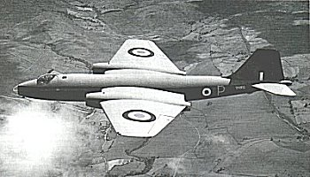  The Canberra B.2, VX165 - A classic shape - (Photo : EE Co Ltd)  A cut-away picture of a B.2 Canberra can be seen here.  The story of the initial design and building of the first Canberra is given in an excellent book The English Electric Canberra by Ken Delve, Peter Green and John Clemons. The authors also make mention of the fact that an order for 90 aircraft was placed before the prototype even flew.  The prototype Canberra, VN799, looked very much as they do today except for a rounded tip to the fin and a long tail-fin strake along the top of the fuselage. The aircraft was painted overall in a light blue colour and taxying trials took place at Warton on 8th May 1949. The test pilot, R.P. Beamont, considered the aircraft more than ready after a few short "hops" under power on the main runway. On Friday 13th May 1949, Beamont lofted the prototype Canberra into the air accompanied by a Vampire chase plane - the Canberra was airborne for the first time. On that Friday 13th, the pilot and designers probably little realised that their aircraft would develope, become a multi-record breaker and go on to serve world-wide with many different Air Forces. I suspect they didn't give much thought either to the possibility that the Canberra would survive to celebrate its 50th anniversary in 1999.  On its entry into service at RAF Binbrook in 1951, the B.2 Canberra was considered to be the replacement bomber for the RAF's Avro Lincolns and B-29 Washington B-1s. These aircraft had themselves replaced the Halifaxes and Lancasters that had given such sterling service for Bomber Command during the, then, recent conflict. | CANBERRA POWER  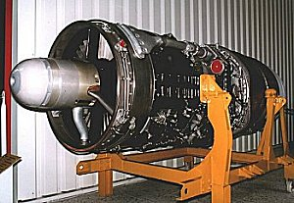  Canberra Power 1 - The Rolls Royce Avon  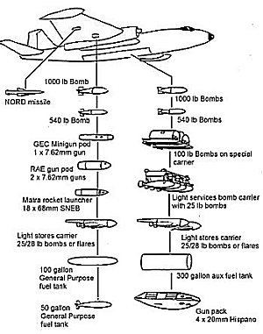  Canberra Power 2 - War Loads  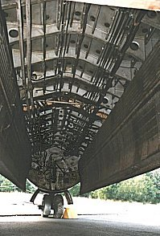  Canberra Power 3 - The Bomb Bay

See also about Canberra in Indian Air Force
http://www.bharat-rakshak.com/IAF/History/1965War/Chapter7.html

and Canberra in Vietnam
http://www.2.ozland.net.au/users/marshall/raaf/2squad.htm

And Canberra with USAF (see below)
http://www.b-57canberra.org/

The B-57 Canberra
Night Intruder

Fifty years ago in 1951, the B-57 was selected (in preference to the Martin XB-51) as the
night-intruder bomber for service in the Korean War.
Always check The Crew Information File (
before flight for the latest updates.
Did you check Mail Call?
Latest item 4 June 2001
Best viewed at 800x 600 resolution
The B-57 Canberra served the U.S. Air Force for more than 25 years as a nuclear weapons platform, conventional weapons bomber, reconnaissance, tow target, weather, and electronic countermeasures aircraft as well as being the mainstay for other nations. This web site is dedicated to the aircrews, maintenance and support personnel who knew the aircraft and were a part of its missions. It is a beginning with the hope that those who were a part of the Canberra story will add to the growth of this site by providing original photos, sound, and anecdotes.  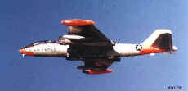  ECM configuration 4713 DSES: photo-Mark Witt  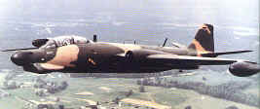  "G" model: Late Vietnam War: photo-Robert Mikesh  Marquis (Mark) Witt  Lt. Col. USAF (Retired)  Mark@B-57Canberra.org | 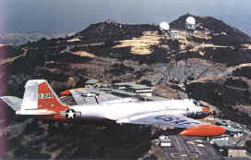  EB-57A model: photo Air Force  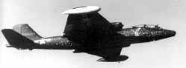  Patricia Lynn Recon leaves for repair: photo-USAF  Tan Son Nhut AB, Vietnam  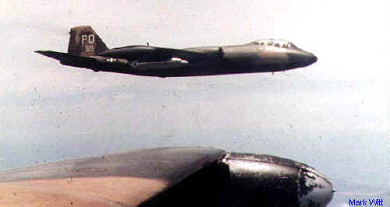  8th TBS Bomber configuration: photo- Mark Witt  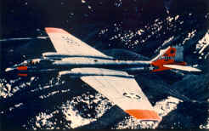  B-57D: photo - Mark Girard  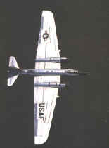  "F" model Recon: photo-Robert Mikesh

The most comprehensive treatment of the B-57 is found in the books by Robert Mikesh. Photos from the books are used with permission.
- Martin B-57 Canberra, the Complete Record
- The B-57 Canberra at War - 1964-1972
My thanks to my son, Tom, for technical help on the site who asked me, " Dad, why didn't you make me learn to fly?", and to Colonel John Harris, a former commander, for his contributions of text, photos and encouragement.
© Copyright Marquis G. Witt, 1998,1999, 2000, 2001. Materials may be freely copied and distributed subject to the inclusion of the copyright notice and the web site address. The site is intended for historical and informational purposes. This site contains links to other Internet sites. These links are not endorsements of any products or services in such sites, and no information in such sites has been endorsed or approved by this site.

