http://www.raf.mod.uk/bob1940/401to601.html

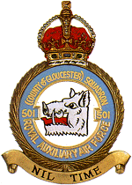
Battle of Britain history of No. 501 Squadron.
Aircraft: Hurricane Mk.1
Motto: Nil time
Badge: A boar's head couped. The boar's head is taken from the Arms of Gloucester; the animal is also noted for its courage.
No 501 Squadron was formed at Filton on 14 June 1929 as a Special Reserve unit and began to receive DH9As for day bomber duties in March 1930. These were replaced by Wapitis in 1930 and, early in 1933, Wallaces came into service. Re-equipped with Harts in July 1936, the squadron had been transferred to the Auxiliary Air Force in May 1936, changing its name to embrace a larger area of recruitment. Hinds were received in March 1938 and at the end of the year No 501 was redesignated a fighter squadron, receiving Hurricanes in March 1939. On the outbreak of World War Two, the squadron flew defensive patrols until the German attack on France in May 1940, when it moved across the Channel to provide fighter cover for the AASF, retiring to Brittany and returning to the UK when France surrendered. No 501 was based in southern England throughout the Battle of Britain.
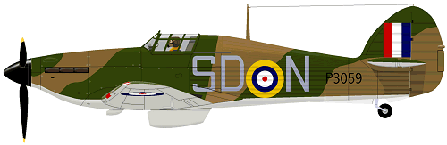
A Hawker Hurricane Mk 1 in 501 Squadron markings
Stations
Croydon 21 June 1040 Middle Wallop 4 July 1940 Gravesend 25 July 1940 Kenley 10 September 1940

